11 Active buzzer Module

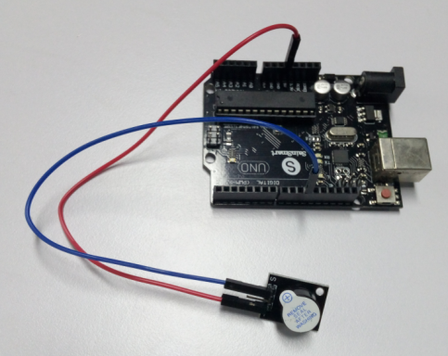

int buzzer=11;

void setup()

{

pinMode(buzzer,OUTPUT);

}

void loop()

{

unsigned char i,j;

while(1)

{

for(i=0;i<80;i++)

{

digitalWrite(buzzer,HIGH);

delay(1);

digitalWrite(buzzer,LOW);

delay(1);

}

for(i=0;i<500;i++)

{

digitalWrite(buzzer,HIGH);

delay(2);

digitalWrite(buzzer,LOW);

delay(2);

}

}

}